Dear Sir/Madam,

Raise a Glass for Brass - Sponsor a Barrel

Emley Brass Band was first set up in 1870 by workers from the local mining community and we’re still very much at the heart of the local community today. As a Charity (Registered Charity Number 1169209) we depend on support from friends, family and our local community so the band can continue to develop and perform.

We are looking for sponsors to help make our 13th Real Ale Festival a huge local success – our last festival attracted more than 350 people from Emley and beyond. All funds raised will be used to refresh our uniform to keep us looking smart on stage.

The Real Ale Festival will be held over the Easter weekend (29th March – 31st March 2024) at Emley Band Room, 9 Beaumont St, Emley, HD8 9RJ.

We offer three levels of sponsorship, please see enclosed Sponsor Form for details:

- Double Barrel £160.00
- Full Barrel £85.00
- Half Barrel £50.00

It couldn’t be easier, simply complete the enclosed form and return to Adam at the above address or contact us via email (realalefestival@emleybrassband.co.uk) for more information.

We look forward to hearing from you.

Emley Brass Band
Registered Charity 1169209

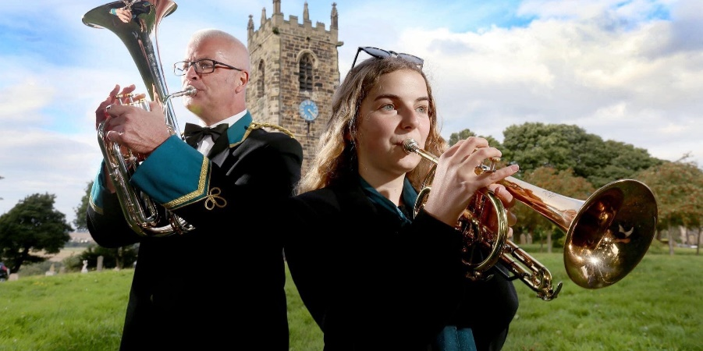

Sponsor Form

Company Name
Contact Name
Contact Number
Email Address
Twitter Handle | @
Web Site

Our company would like to sponsor:
- Double Barrel - £160.00
    - Bar – Logo / Company name on your two ale pumps at the bar
    - Tasting Notes – Logo / Company Name next to two ales in the programme
    - A5 Programme – Full Page Advert (Portrait)
    - Website – Your company listed on our website with link to your website
    - Social Media – Your support advertised on Facebook & Twitter
    - Your Literature - Banners / Flyers at the event
    - Complimentary Drinking Tokens

- Full Barrel - £85.00
    - Bar – Logo / Company name on your ale’s pump at the bar
    - Tasting Notes – Logo / Company Name next to your ale in the programme
    - A5 Programme – Half Page Advert (landscape)
    - Website – Your company listed on our website with link to your website
    - Social Media – Your support advertised on Facebook & Twitter
    - Your Literature - Banners / Flyers at the event

- Half Barrel - £50.00
    - Bar – Logo / Company name on your shared ale’s pump at the bar
    - Tasting Notes – Logo / Company Name next to your shared ale in the programme
    - A5 Programme – Quarter Page Advert (portrait)
    - Website – Your company listed on our website with link to your website
    - Social Media – Your support advertised on Facebook & Twitter

Payment Details

Cheque: Payable to “Emley Brass Band” and sent to 101 Highfield Road, Brighouse, HD6 3JA
Bank Transfer: Emley Brass Band, Sort Code: 30-94-43, Acc No: 87624468, Reference: Ale 2023

